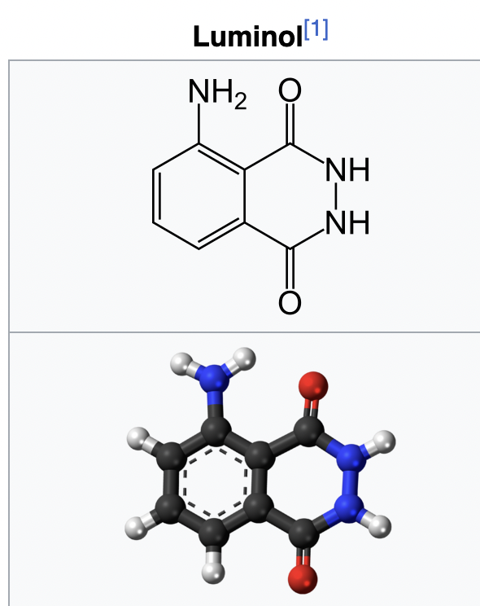
fawm 2025

33 luminol february 20-21, 2025

Luminol (C8H7N3O2) is a chemical that exhibits chemiluminescence,
with a blue glow, when mixed with an appropriate oxidizing agent.
Luminol is a white-to-pale-yellow crystalline solid that is soluble in most polar organic solvents but insoluble in water.
Forensic investigators use luminol to detect trace amounts of blood
at crime scenes, as it reacts with the iron in hemoglobin.
Biologists use it in cellular assays to detect copper, iron, and cyanides
as well as specific proteins via western blotting.
When luminol is sprayed evenly across an area, trace amounts
of an activating oxidant make the luminol emit a blue glow that can be seen
in a darkened room. The glow only lasts about 30 seconds but can be documented photographically. The glow is stronger in areas receiving more spray; the intensity of the glow does not indicate the amount of blood or other activator present.

Theory
Crime scene investigators use luminol to find traces of blood, even if someone has cleaned or removed it. The investigator sprays a solution of luminol and the oxidant. The iron in blood catalyses the luminescence. The amount of catalyst necessary to cause the reaction is very small relative to the amount of luminol, allowing detection of even trace amounts of blood. The blue glow lasts for about 30 seconds per application. Detecting the glow requires a fairly dark room. Any glow detected may be documented by a long-exposure photograph.

Drawbacks
Luminol's use in a crime scene investigation is somewhat hampered by the fact that it reacts to iron- and copper-containing compounds,[15] bleaches, horseradish, fecal matter, and cigarette smoke residue. Application of luminol to a piece of evidence may prevent other tests from being performed on it; however, DNA has been successfully extracted from samples exposed to luminol.

fawm 2025

33 luminol february 20-21, 2025

Circus wrapping paper and rubber bands
he looks to find what lies within
And I wish that I was soberer…
He turns it over and over in his hands
the bracelet that I game to him...
He doesn’t know your blood’s all over it.

Your memory
bathed in fleeting blue.
The scars and the stains.
I remember you.

Luminol
Luminol
They don’t remember you at all.

A young virtuoso never knows what to expect
or what kind of song to sing
Gotta wait till you discover it.
He moves his fingers deftly up and down the neck
I never even changed the strings
He doesn’t know your blood’s all over it.

Your rhapsody
bathed in fleeting blue.
The chords and discords.
I remember you.

Luminol
Luminol
They don’t remember you at all.

Luminol
Luminol
They don’t remember you at all.

