fawm 2025

2 down into nite february 1-2, 2025

descending in the evening … but it’s always evening somewhere
and there’s a line across the world down below that marks the last of the evening light
seeing the world from 20 thousand feet through this rarefied air
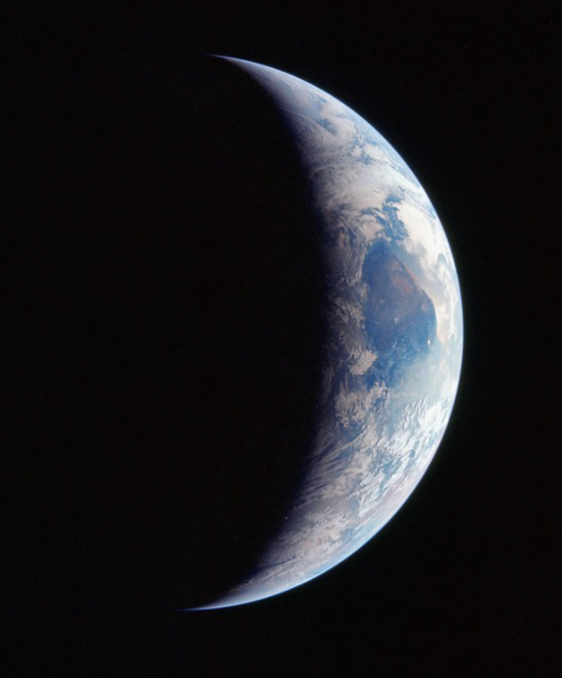
crossing over to the other side … descending down into nite

down into nite
down in tonite
descending
down into nite

inserting oneself into a feeling … where the long night’s a season of its own
and there’s so much to be done / while the sun / ‘s still sleeping out of sight
breathing in the crystals and the darkness in this petrified air
building an outpost on the other side … descending down into nite

down into nite
down in tonite
descending
down into nite

the long slow road to believing … when the nighttime hides the reasons to believe
it’s a singular garden grows / as time slows / in the absence of warmth and light
peering out at nothing in all directions in unverified air
softening and hardening … descending down into nite

