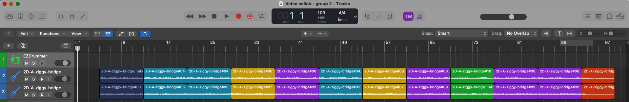
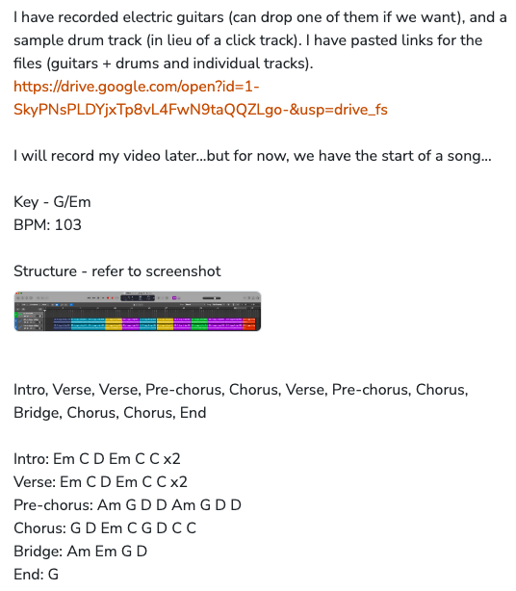

intro

V1

V2

pre-chorus

chorus

V3

pre-chorus

chorus

BRIDGE

chorus

chorus

end

