#23 fawm XX 2023

travel – edna st. vincent millay

The railroad track is miles away,
And the day is loud with voices speaking,
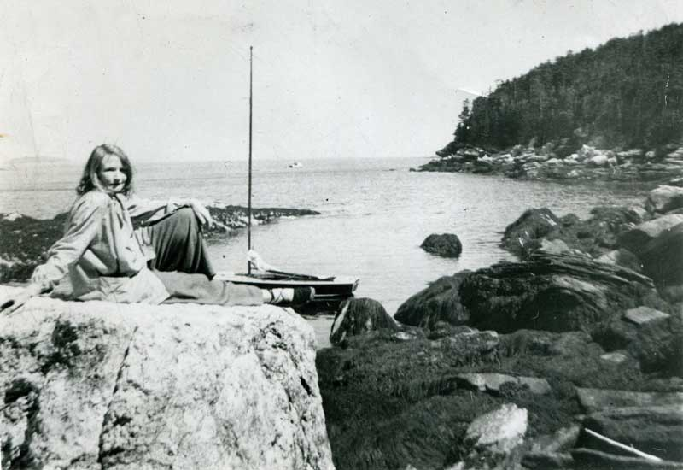
Yet there isn't a train goes by all day
But I hear its whistle shrieking.
All night there isn't a train goes by,
Though the night is still for sleep and dreaming
But I see its cinders red on the sky,
And hear its engine steaming.
My heart is warm with the friends I make,
And better friends I'll not be knowing,
Yet there isn't a train I wouldn't take,
No matter where it's going.

