#11 fawm XX 2023

river generations

norm and john and dan, they wrote of rivers
and i read the words of norm and john and dan
in farflung watersheds i stumbled on ‘em
it takes time to see where the riverbeds began
the first book starts with norm and paul in montana youth
first book ends with norm’s children, jean and john
the words linger beneath the rocks under the river
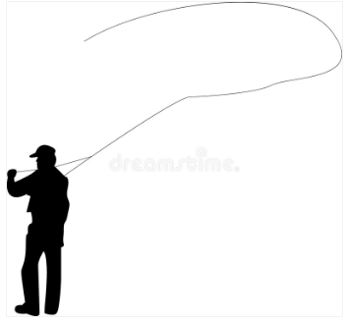
the water flows and the western tale goes on

norm and john and dan, they wrote of waters
and i’ve paddled along with norm and john and dan
all the way to unalakleet from whitehorse
with the alaska river bible in my hands
the second book is paddling the yukon
i gave no second thoughts to the author’s name
just soaking in descriptions of the wildlands
carefully crafted by some guy named dan maclean

norm and john and dan, they wrote stories
now the days go fast but the waters still flow slow
artifacts wash up along the shoreline
some tales erode … some tales grow
the third book spills the home waters
connects some reservoirs the others had begun
connecting family chronicles of americana
norm and john and dan, grandfather and dad and son

