#7 fawm XX 2023
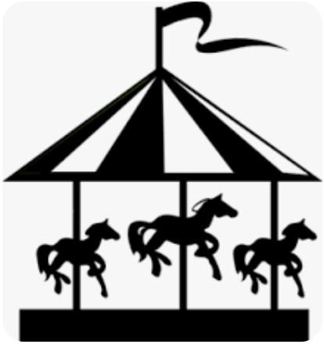
what i left across the pond

aaaaaaaaaaaaaaaaaaaaaaaa

cloud system satellites on the telly
chinese balloons circling le monde
itz a small small world and getting smaller
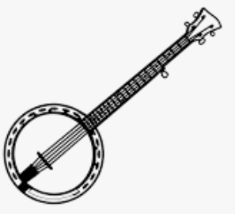
but itz still a long long hop back across that pond

what was i thinking?
what’s coming down the pike here for me?
i left my heart with stick-around kelly
i left my banjo across the sea

there’s more songs now than i could ever sample

there’s still mary lou and evan doing the bevis frond
there’s a road rolling off in all directions
towards the faraway of which i’ve grown so fond

what was i hoping?
what’s the point of this transatlantic trek?
i left my swag in the snow at the end of bias.
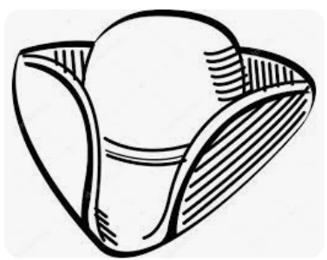
i left my banjo back in Czech.

můj nastroj jsem daleko nechal
drei Ecken hat mein Hut
já nevím, na co jsem čekal
die Flasche oder das Boot

1809 was one of my favourites
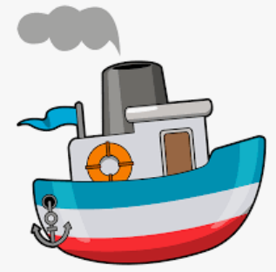
Lincoln Darwin waved that magic wand
think i heard yesterday was such an easy game to play…
itz been a long long slog out of the pond

what was i dreaming?
i’ve forgotten now how dreams are supposed to work…
i left my best years back there in the maelstrom.
i left my banjo with an expat in the ‘Perk.

